Monitoring / On-Call Approval Form

Employee Name: Nikunj Adhaduk _

Manager Name: Yaser Shadmehr
.
Monitoring Hours
Date of Monitoring (mm/dd/yyyy) | Project | Reason | Number of Hours
8/31/2025 – 9/06/2025 | Scene | OKTA hyper care and hotfix monitoring | 3.5
TOTAL |  |  | 3.5

On-Call Payment
Dates On-Call (mm/dd/yyyy – mm/dd/yyyy) | # of Weeks | Rate
8/17/2025 – 8/23/2025 | 1 | 200
8/24/2025 – 8/30/2025 | 1 | 200
8/31/2025 – 9/06/2025 | 1 | 200
TOTAL |  | 600
Approvals
Employee Signature: 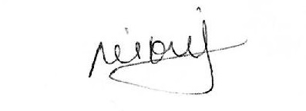 | Date:  Sept 10, 2025
Manager Signature: | Date:  Sept 10, 2025

Please submit to Payroll once approved.

Description
Date of Monitoring | Hours | Reason
Aug 20, 2025 | 3 | July 30 PROD slot deployment 3 to 6 PM
Aug 28, 2025 | 1.5 | OKTA first migration file support after hours before handing it over to DBA and Lead Dev
Sept 4, 2025 | 6 | OKTA full Prod Deployment
Sept 4, 2025 | 2 | OKTA HOT-Fix support after deployment for SQL datatype fix
Sept 4, 2025 | 1.5 | OKTA Hypercare support

